

Programme Name: ________**BCS HONS**_______________________________________

Course Code: __**MATH 1023**________

Course Name: ________**Additional Mathematics**___________________________

**Mathematics Individual Project Work**

Date of Submission: ______**9/24/2020**_____________

**Submitted By: Submitted To:**

Student Name**: Dipesh Tha Shrestha** Faculty Name**: SHANTA RAYAMJHI BASNET**

IUKL ID: **041902900028** Department**: LMS**

Semester**: Second Semester**

Intake**: September 2019**

1.

1. Three numbers are in the ratio of 1:2:4. If 3 is added to the first and 8 is subtracted from the third then the new numbers will be in Arithmetic Progression. Find the numbers.

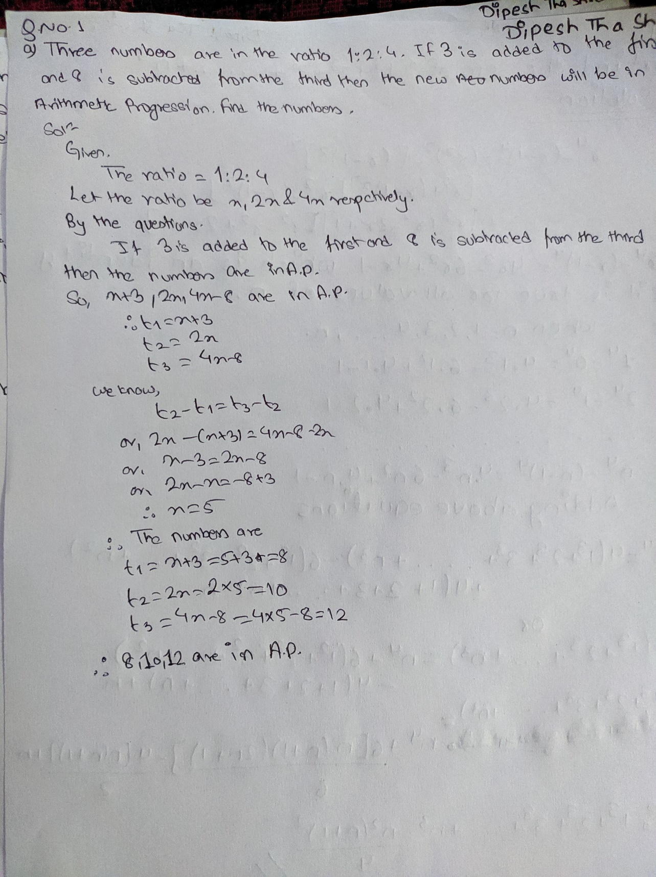

1. Find the sum of: 13 + 23 + 33+ … …+ n3

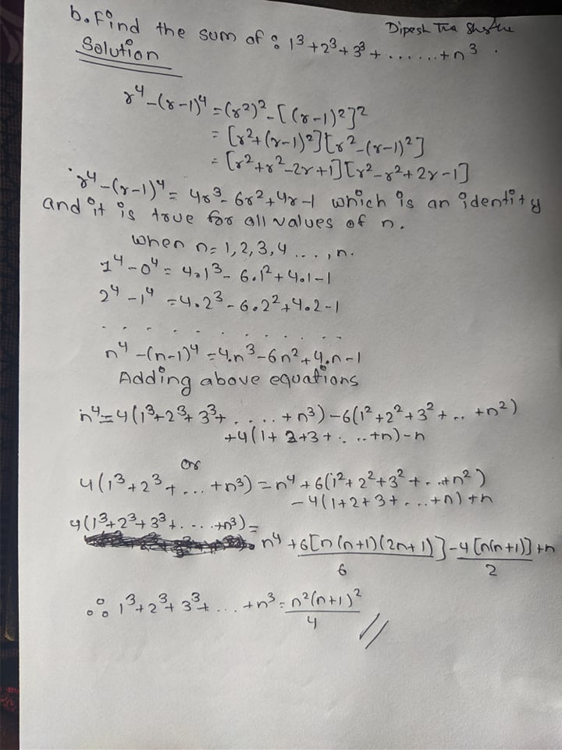

2. From the top of a 200 meters high building, the angle of depression to the bottom of a second building is 20 degrees. From the same point, the angle of elevation to the top of the second building is 10 degrees. Calculate the height of the second building.

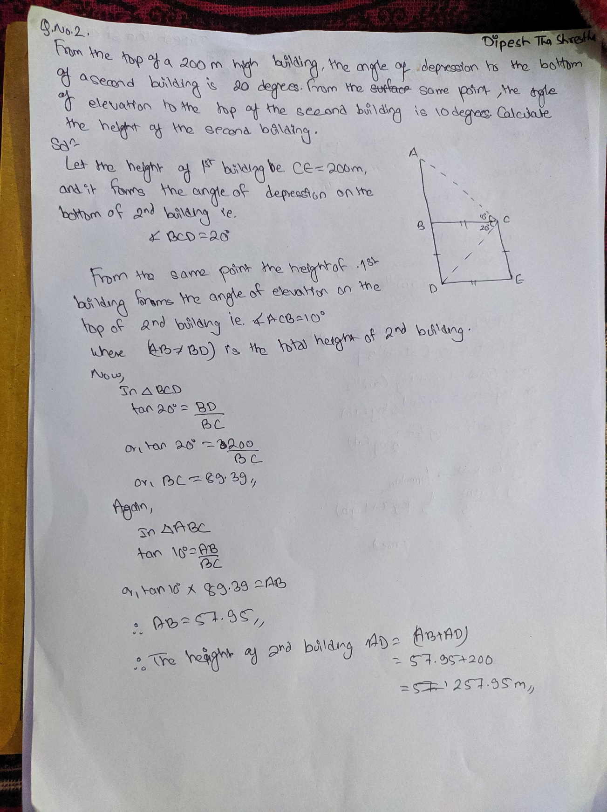

3. Prove that:

* 1. Log (a + b)/3=1/2(log a +log b) if a2+b2=7ab

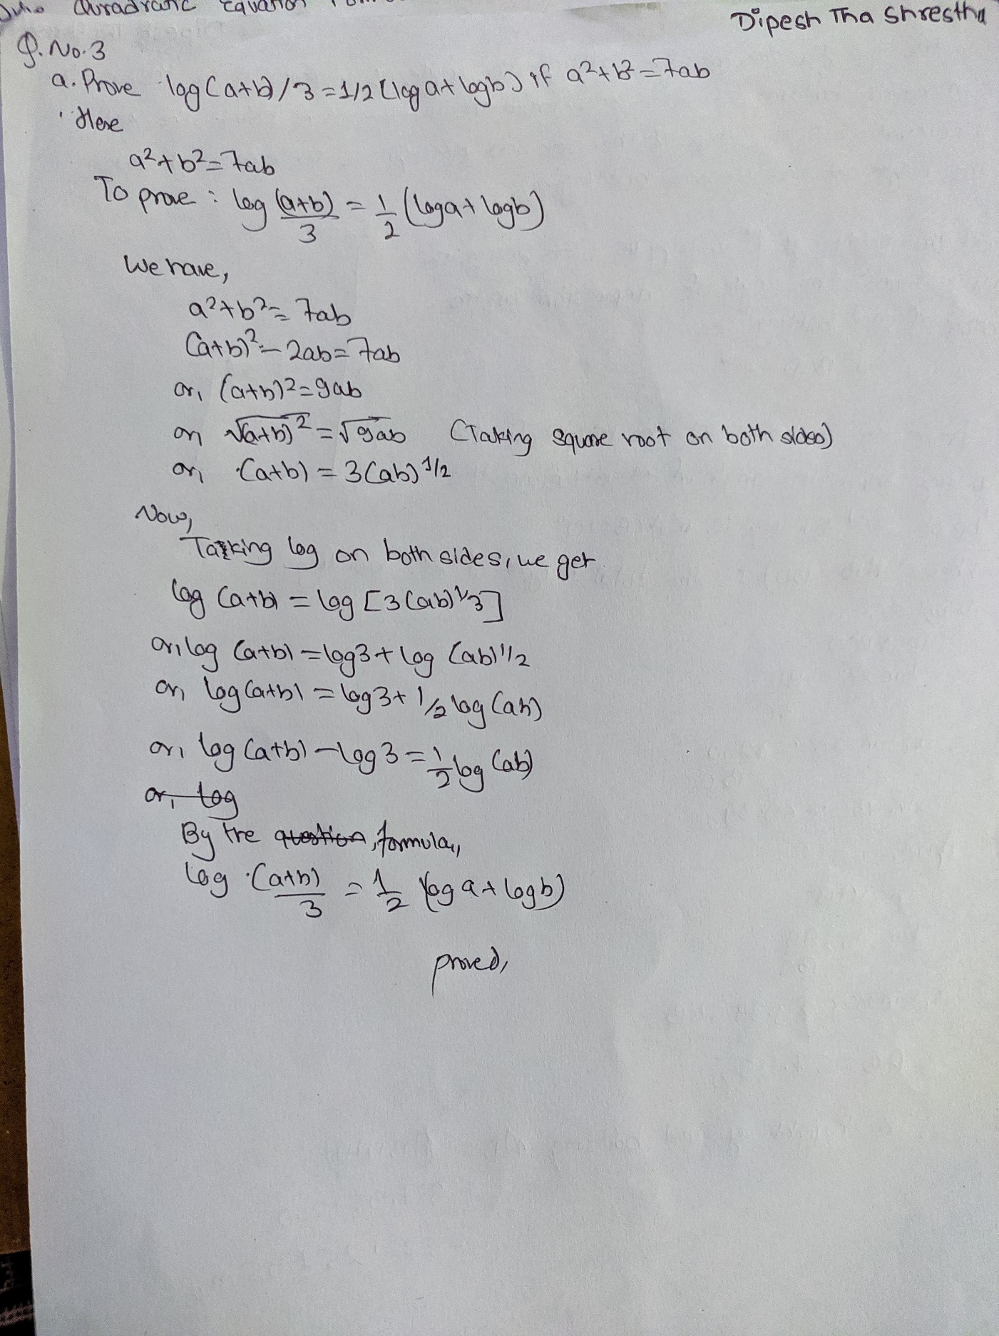

* 1. 𝑥+11+𝑦+11+𝑧+11 = 1 If x=log𝑎bc, y=log𝑏ca, z = log𝑐ab

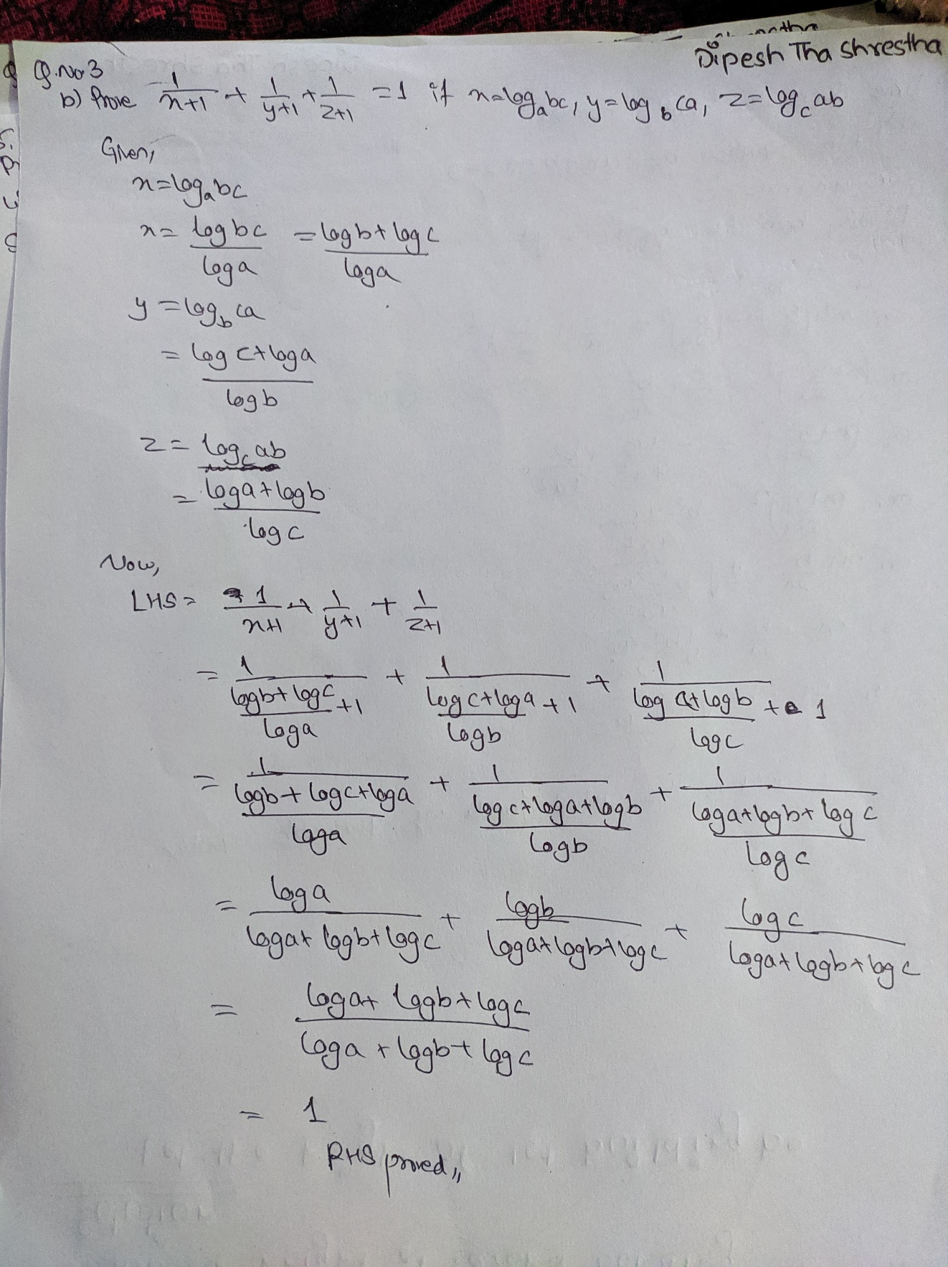

4.

1. Drive Quadratic Equation Formula. 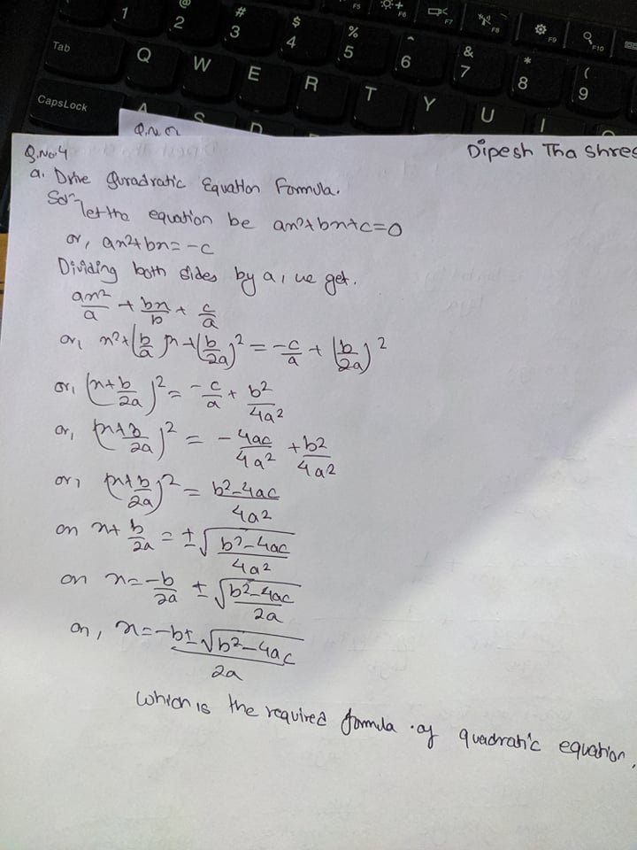
2. Discuss the nature of the roots of the quadratic equation 2x2 – 8x + 3 = 0. 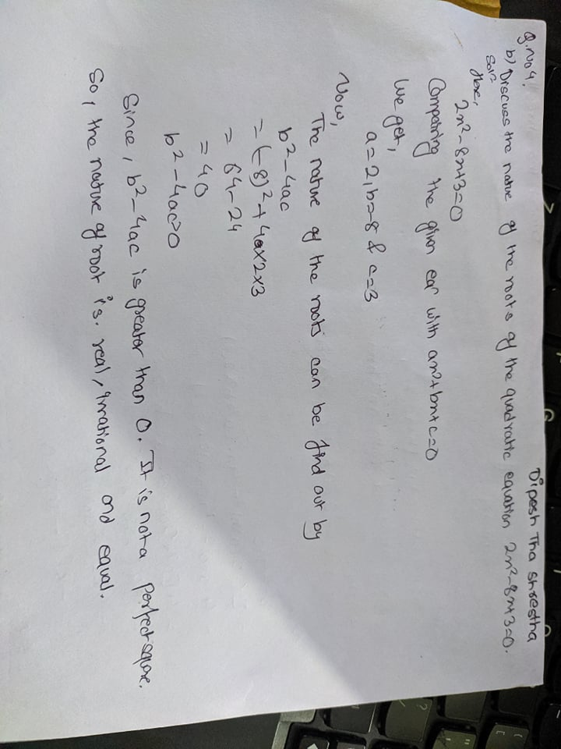

5.

1. Prove that the roots of the equation x2-2(a+b)x+a2+b2+2c2 = 0 will be imaginary.

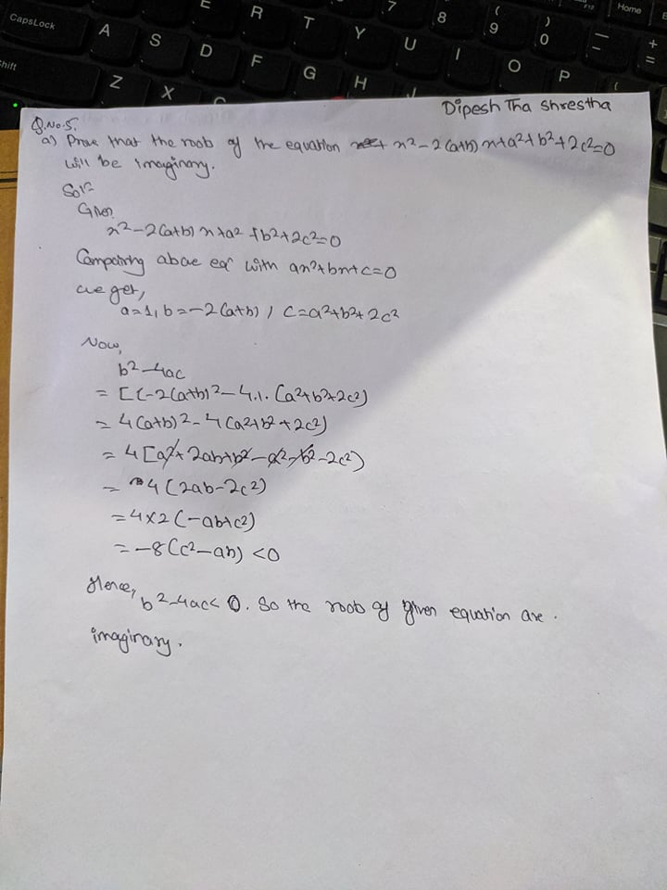

1. If α and β be the roots of x2 + px + q = 0, find the quadratic equation whose roots are α/β and β/α

